**A MINI PROJECT REPORT**  
**ON**  
**Sign Language Recognition Using Hand Gestures**

Submitted to Mumbai University  
In the partial fulfillment of the requirement for the award of the degree of  
**Bachelor of Engineering**

In  
**COMPUTER ENGINEERING**

By  
**Mr. Shadab Shaikh.**   
**(17DCO74.)**

Under the guidance of  
**Mr. Muhammed Salman Shamsi**

**Assistant Professor**



**Department of Computer Engineering**  
**Anjuman-I-Islam’s Kalsekar Technical Campus**

**Affiliated to Mumbai University**

KHANDA GOAN, NEW PANVEL, NAVI MUMBAI, MAHARASHTRA

2018-2019

**Department of Computer Engineering**  
**Anjuman-I-Islam’s Kalsekar Technical Campus**

**Affiliated to Mumbai University**

KHANDA GAON, NEW PANVEL, NAVI MUMBAI, MAHARASHTRA

2018-2019



**DECLARATION BY THE CANDIDATE**

**Shadab Shaikh** bearing **Roll number: 17DCO74**, hereby declare that the mini project report entitled **“Sign language recognition using hand gestures”**, is a record of bonafide work carried out by me and the results embodied in this project have not been reproduced or copied from any source. The results of this project report have not been submitted to any other University or Institute for the award of any other Degree or Diploma.

**Shadab Shaikh**

**17DCO74**

**Department of Computer Engineering**  
**Anjuman-I-Islam’s Kalsekar Technical Campus**

**Affiliated to Mumbai University**

KHANDA GAON, NEW PANVEL, NAVI MUMBAI, MAHARASHTRA

2018-2019



**CERTIFICATE**

This is to certify that the project report entitled **“Sign language detection using hand gestures”**, submitted by **Mr. Shadab Shaikh**, bearing **Roll. No.: 17DCO74** in the partial fulfillment of the requirements for the award of the degree of **Bachelor of Computer Engineering** is a record of bonafide work carried out by him for the course **Mini Project CSM605**.

**Mini Project Guide**

**(Prof. Muhammed Salman Shamsi)**

**Mini Project Coordinator**

**(Prof. Muhammed Salman Shamsi)**

**Program Owner**

**(Prof. Tabrez Khan)**

**INDEX**

**CONTENTS**

CH**APTER 1: INTRODUCTION**

* 1. Introduction……………………………………………00
  2. Scope…………………………………………………..03
  3. Problem Statement……..………...................................03

**CHAPTER 2 SYSTEM SPECIFICATION**

2.1 System Requirement……………………………………26

2.2 System Features……………………………………...…26

**CHAPTER 3: SYSTEM DESIGN**

3.1 System Architecture…………...………………………. 47

3.2 Modules in the System………...………………………. 47

3.3 Use Case Diagram ………...…………………………... 47

3.4 Activity Sequence Diagram………......……………...... 47

**CHAPTER 4: IMPLEMENTATION**

4.1 Code Snippets………..…..……….…….…………........50

4.2 Screen Shots…...………………………………………..70

**CHAPTER 5: CONCLUSION**

5.1 Conclusion….…………………………………………..75

5.1 Future Scope....…………………………………………..75

**REFERENCES**...…………………………………………………………... 76

**CHAPTER 1**

**INTRODUCTION**

**1.1 INTRODUCTION**

Some of the major problems faced by a person who are unable to speak is they cannot express their emotion as freely in this world. Use that voice recognition and voice search features in smartphone(s). Audio results cannot be retrieved. They are unable to use (Artificial Intelligence/personal Butler) like google assistance, or Apple's SIRI etc. because all those apps are based on voice controlling.

There is a need for such platforms for such kind of people. American Sign Language (ASL) is a complete, complex language that employs signs made by moving the hands combined with facial expressions and postures of the body. It is the primary language of many North Americans who are deaf and is one of several communication options used by people who are deaf or hard-of-hearing.

While sign language is very important to deaf-mute people, to communicate both with normal people and with themselves, is still getting little attention from the normal people. The importance of sign language has been tending to ignored, unless there are areas of concern with individuals who are deaf-mute. One of the solutions to communicate with

the deaf-mute people is by using the services of sign language. But the usage of sign language interpreter can be costly.

Hand gesture is one of the methods used in sign language for non-verbal communication. It is most commonly used by deaf & dumb people who have hearing or speech problems to communicate among themselves or with normal people. Various sign language systems have been developed by many makers around the world but they are neither flexible nor cost-effective for the end users.

**1.2 SCOPE**

One of the solutions to communicate with the deaf-mute people is by using the services of sign language interpreter. But the usage of sign language interpreter can be costly. Cheap solution is required so that the deaf-mute and normal people can communicate normally.

Our strategy involves implementing such an application which detects pre-defined

American signed language (ASL) through hand gestures. For the detection of movement of gesture, we would use basic level of hardware component like camera and interfacing is required. Our application would be a comprehensive User-friendly Based system built on PyQt5 module.

Instead of using high-end technology like gloves or kinect, we aim to solve this problem using state of the art computer vision and machine learning algorithms.

This application will comprise of two core module one is that simply detects the gesture and displays appropriate alphabet. The second is after a certain amount of interval period the scanned frame would be stored into buffer so that a string of character could be generated forming a meaningful word.

Additionally, an-addon facility for the user would be available where a user can build their own custom-based gesture for a special character like period (.) or any delimiter so that a user could form a whole bunch of sentences enhancing this into paragraph and likewise. Whatever the predicted outcome was, it would be stored into a .txt file.

**1.3 PROBLEM STATEMENT**

Given a hand gesture, implementing such an application which detects pre-defined American signed language (ASL) in a real time through hand gestures and providing facility for the user to be able to store the result of the character detected in a txt file, also allowing such users to build their customized gesture so that the problems faced by persons who aren’t able to talk vocally can be accommodated with technological assistance and the barrier of expressing can be overshadowed.

**CHAPTER 2**

**SYSTEM SPECIFICATION**

**2.1 SYSTEM REQUIREMENT**

**2.1.1 HARDWARE REQUIREMENTS**

* Intel Core i3 3rd gen processor or later
* 200Mb disk space
* 1 GB RAM
* Any external or inbuild camera with minimum pixel resolution 200 x 200 (300ppi or 150lpi) 4-megapixel cameras and up.

**2.1.2 SOFTWARE REQUIREMENTS**

* Microsoft Windows XP or later / Ubuntu 12.0 LTS or later /MAC OS 10.1 or later
* Python Interpreter (3.7 or later)
* TensorFlow framework, Keras API
* PyQT5, Tkinter module
* Python OpenCV2, scipy, runpy, qimage2ndarray, win32api, winGuiAuto, win32gui, win32con, keyboard, pyttsx3, sys libraries

**2.2 SYSTEM FEATURES**

* User-friendly based GUI built using industrial standard PyQT5.
* Real time American standard character detection based on gesture made by user.
* Customized gesture generation.
* Forming a stream of sentences based on the gesture made after a certain interval of time.

**CHAPTER 3**

**SYSTEM DESIGN**

**3.1 SYSTEM ARCHITECTURE**

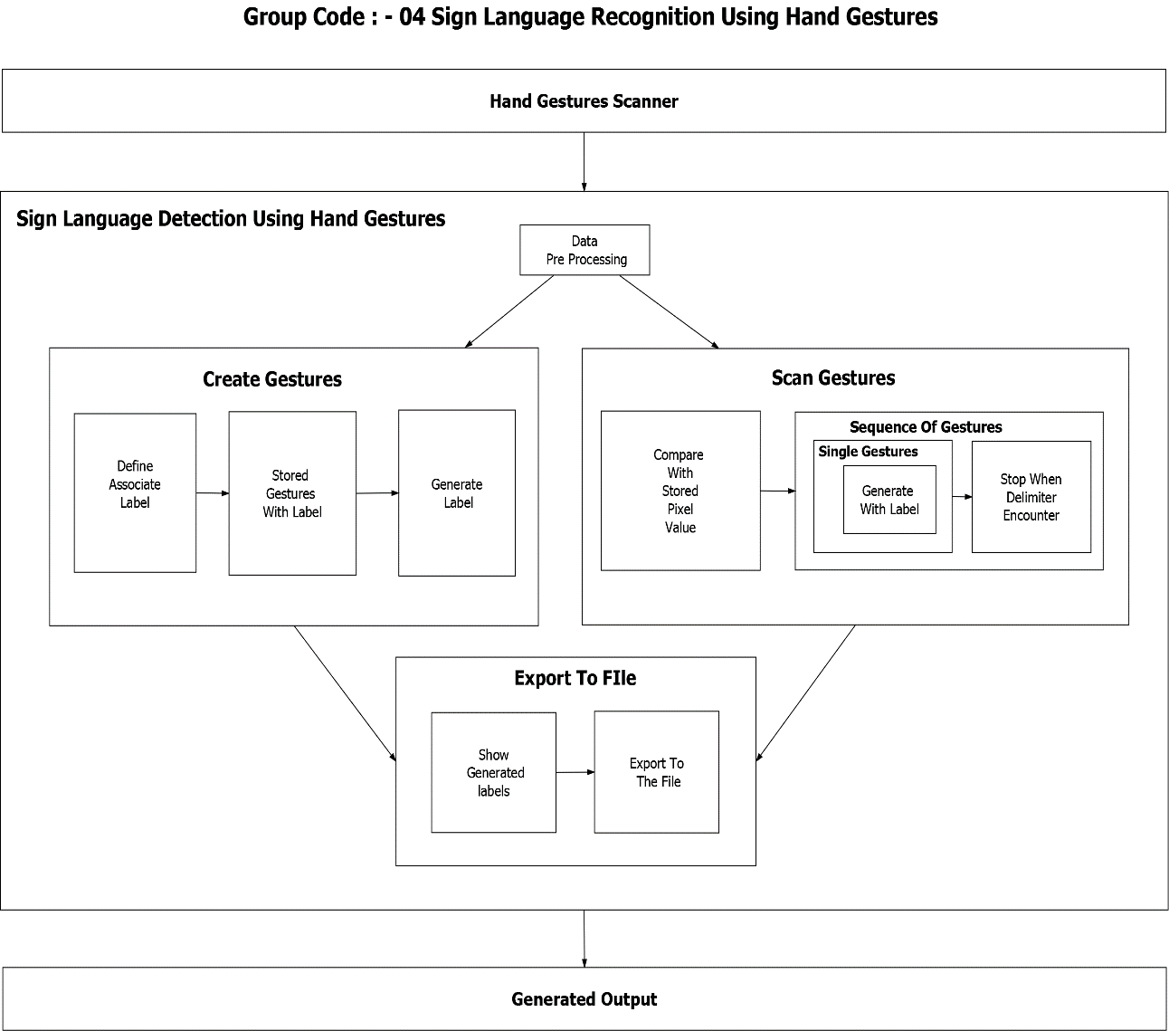

**Fig 1: System Architecture for Sign Language Recognition Using Hand Gestures.**

**3.2 MODULES IN THE SYSTEM**

* **Data Pre-Processing –** In this module, based on the object detected in front of the camera its binary images is being populated. Meaning the object will be filled with solid white and background will be filled with solid black. Based on the pixel’s regions, their numerical value in range of either 0 or 1 is being given to next process for modules.
* **Scan Single Gesture –** A gesture scanner will be available in front of the end user where the user will have to do a hand gesture. Based on Pre-Processed module output, a user shall be able to see associated label assigned for each hand gestures, based on the predefined American Sign Language (ASL) standard inside the output window screen.
* **Create gesture –**A user will give a desired hand gesture as an input to the system with the text box available at the bottom of the screen where the user needs to type whatever he/she desires to associate that gesture with. This customize gesture will then be stored for future purposes and will be detected in the upcoming time.
* **Formation of a sentence –** A user will be able to select a delimiter and until that delimiter is encountered every scanned gesture character will be appended with the previous results forming a stream of meaning-full words and sentences.
* **Exporting –** A user would be able to export the results of the scanned character into an ASCII standard textual file format.

**3.3 USE CASE DIAGRAM**

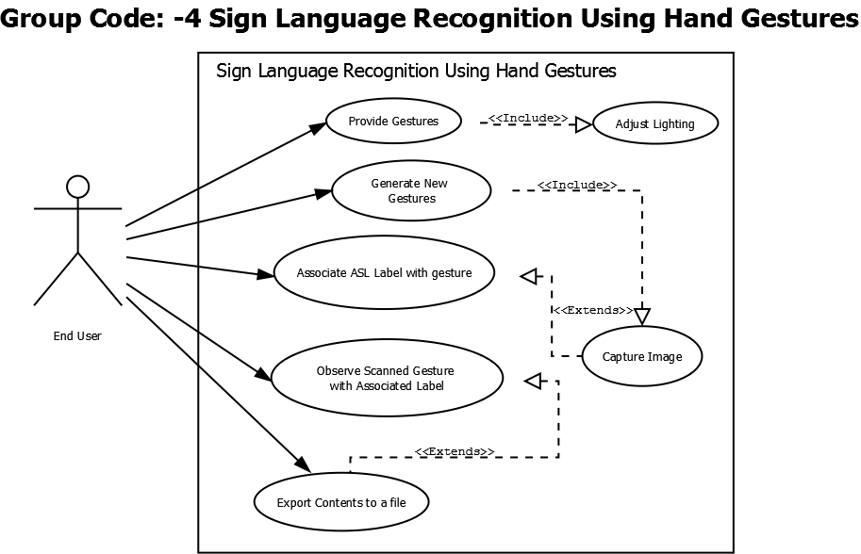

**Fig 2: Use Case Diagram for Sign Language Recognition Using Hand Gestures.**

**3.4 ACTIVITY DIAGRAM**

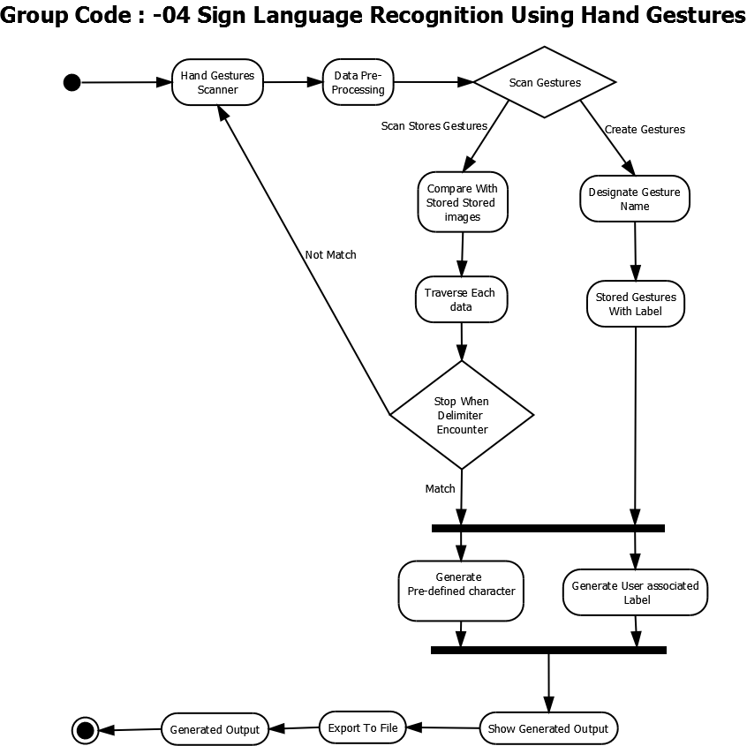

**Fig 3: Activity Diagram for Sign Language Recognition Using Hand Gestures.**